
Mehran University of Engineering & Technology Jamshoro
Subject: Electronic Instrumentation Systems
Assignment
Submitted by
DANIYAL 22ES077

Smart Solar Tracking System Using Machine Learning
1. Introduction
With the increasing demand for renewable energy, solar energy systems have become highly important. Traditional solar panels are fixed and cannot follow the sun’s movement, which reduces efficiency. A solar tracking system improves efficiency by aligning the panel with the direction of maximum sunlight.
In this project, a solar tracking system is developed using Light Dependent Resistors (LDRs), an Arduino microcontroller, and a servo motor. To enhance system intelligence, Machine Learning (ML) is applied to predict the optimal direction of movement based on sensor data.

2. Instrumentation System Description
Components Used:
- LDR Sensors (2)
- Arduino (Uno/ESP32)
- Servo Motor
- Resistors (for voltage divider)
- Power Supply
Working Principle:
- Two LDRs are placed on opposite sides.
- Each LDR measures light intensity.
- Arduino reads analog values from both sensors.
- Based on difference in light intensity, the servo rotates towards the brighter side.
System Flow:

3. Data Collection Method
Data was collected using the Arduino serial monitor.
Parameters Recorded:
- LDR1 (Left sensor value)
- LDR2 (Right sensor value)
- Direction (LEFT / CENTER / RIGHT)
Dataset Size:
- Approximately 500–1000 samples collected at different times (morning, noon, evening).
Sample Data:
LDR1 | LDR2 | Direction
882 | 689 | LEFT
839 | 315 | LEFT
948 | 907 | CENTER
802 | 303 | LEFT
948 | 907 | CENTER

4. Data Preprocessing
The dataset was processed using Python in Google Colab.
Steps Performed:
- Loaded dataset using pandas (File: ldr_dataset.csv)
- Checked for missing values
- Cleaned noisy data
- Encoded categorical output (Direction) into numeric values:
  - LEFT = 0
  - CENTER = 1
  - RIGHT = 2

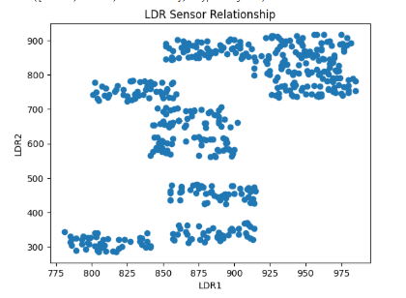
Figure 1: LDR1 vs LDR2 Sensor Distribution
The graph shows the relationship between LDR1 and LDR2 values, indicating variation in light intensity across sensors.
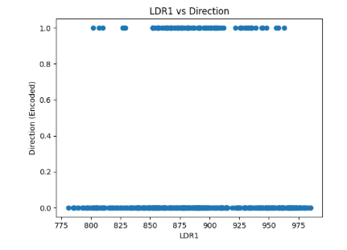
Figure 2: LDR1 vs Direction Relationship

Visualization:
- Scatter plots were generated:
  - LDR1 vs LDR2
  - LDR1 vs Direction

5. Machine Learning Method
Model Used:
Decision Tree Classifier
Reason for Selection:
- Simple and easy to interpret
- Works well with small datasets
- Suitable for classification problems
- Can model non-linear relationships
Model Inputs and Outputs:
- Inputs: LDR1, LDR2
- Output: Direction (LEFT, CENTER, RIGHT)
Training Process:
- Dataset split into training (80%) and testing (20%)
- Model trained using Decision Tree algorithm

6. Results and Analysis
Model Performance:
- Accuracy was calculated using test data
- Confusion matrix used to evaluate prediction performance
Observations:
- Model successfully classified direction based on LDR values
- High accuracy achieved for most test cases
- System shows improvement over simple threshold-based logic
Graphs Included:
- Sensor distribution graph
- Direction classification graph
- Accuracy bar chart
- Confusion matrix
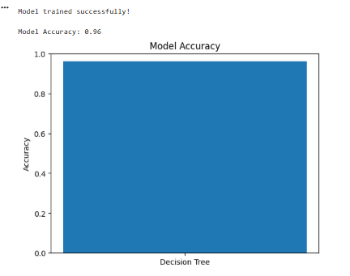
Figure 3: Model Accuracy
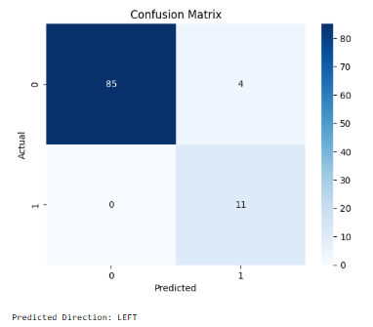
Figure 4: Confusion Matrix of Classification Results

7. System Integration
The ML model enhances the traditional solar tracking system by providing intelligent decision-making.
Traditional System:
- Uses fixed if-else conditions
ML-Based System:
- Predicts direction using trained model
- More adaptive and accurate
Intelligent Features:
- Automatic direction prediction
- Improved tracking accuracy
- Reduced manual tuning

8. Conclusion
A smart solar tracking system was successfully developed using Machine Learning. The Decision Tree model effectively predicts the direction of maximum light intensity based on LDR sensor data. The integration of ML improves system intelligence and performance compared to traditional methods.
This approach demonstrates how ML can be applied in electronic instrumentation systems for smarter control and decision-making.

9. Future Work
- Real-time integration of ML model with Arduino
- Use of advanced algorithms (Random Forest, Neural Networks)
- Implementation of predictive angle control
- Cloud-based monitoring system
10. References
- Light Dependent Resistor (LDR) Working Principle
https://www.electronics-tutorials.ws/io/io_4.html
- Solar Tracking System Basics
https://www.sciencedirect.com/topics/engineering/solar-tracking-system
- Scikit-learn Documentation
https://scikit-learn.org/stable/
- How To Make Solar Tracking System Using Arduino UNO | Step by step 🌞 | Single Axis Solar Tracker - YouTube
11. Python (ML) Code
import pandas as pd
import matplotlib.pyplot as plt
import seaborn as sns

# -----------------------------
# 1. Load Dataset
# -----------------------------
data = pd.read_csv("ldr_dataset.csv")

print("First 5 rows:")
print(data.head())

print("\nColumns:")
print(data.columns)

# -----------------------------
# 2. Graph 1: LDR1 vs LDR2
# -----------------------------
plt.figure()
plt.scatter(data['LDR1'], data['LDR2'])
plt.xlabel("LDR1")
plt.ylabel("LDR2")
plt.title("LDR Sensor Relationship")
plt.show()
plt.close()

# -----------------------------
# 3. Encode Labels
# -----------------------------
data['Direction_encoded'] = data['Direction'].map({
'LEFT': 0,
'CENTER': 1,
'RIGHT': 2
})

# -----------------------------
# 4. Graph 2: LDR1 vs Direction
# -----------------------------
plt.figure()
plt.scatter(data['LDR1'], data['Direction_encoded'])
plt.xlabel("LDR1")
plt.ylabel("Direction (Encoded)")
plt.title("LDR1 vs Direction")
plt.show()
plt.close()

# -----------------------------
# 5. ML Model Training
# -----------------------------
from sklearn.model_selection import train_test_split
from sklearn.tree import DecisionTreeClassifier

X = data[['LDR1', 'LDR2']]
y = data['Direction_encoded']

X_train, X_test, y_train, y_test = train_test_split(X, y, test_size=0.2)

model = DecisionTreeClassifier()
model.fit(X_train, y_train)

print("\nModel trained successfully!")

# -----------------------------
# 6. Predictions
# -----------------------------
y_pred = model.predict(X_test)

# -----------------------------
# 7. Accuracy
# -----------------------------
from sklearn.metrics import accuracy_score

accuracy = accuracy_score(y_test, y_pred)
print("\nModel Accuracy:", accuracy)

# -----------------------------
# 8. Graph 3: Accuracy Plot
# -----------------------------
plt.figure()
plt.bar(["Decision Tree"], [accuracy])
plt.ylim(0, 1)
plt.title("Model Accuracy")
plt.ylabel("Accuracy")
plt.show()
plt.close()
# -----------------------------
# 9. Graph 4: Confusion Matrix
# -----------------------------
from sklearn.metrics import confusion_matrix

cm = confusion_matrix(y_test, y_pred)

plt.figure()
sns.heatmap(cm, annot=True, fmt='d', cmap="Blues")
plt.xlabel("Predicted")
plt.ylabel("Actual")
plt.title("Confusion Matrix")
plt.show()
plt.close()

# -----------------------------
# 10. Test Prediction
# -----------------------------
sample = pd.DataFrame([[800, 400]], columns=['LDR1', 'LDR2'])
prediction = model.predict(sample)

direction_map = {0: "LEFT", 1: "CENTER", 2: "RIGHT"}

print("\nPredicted Direction:", direction_map[prediction[0]])

